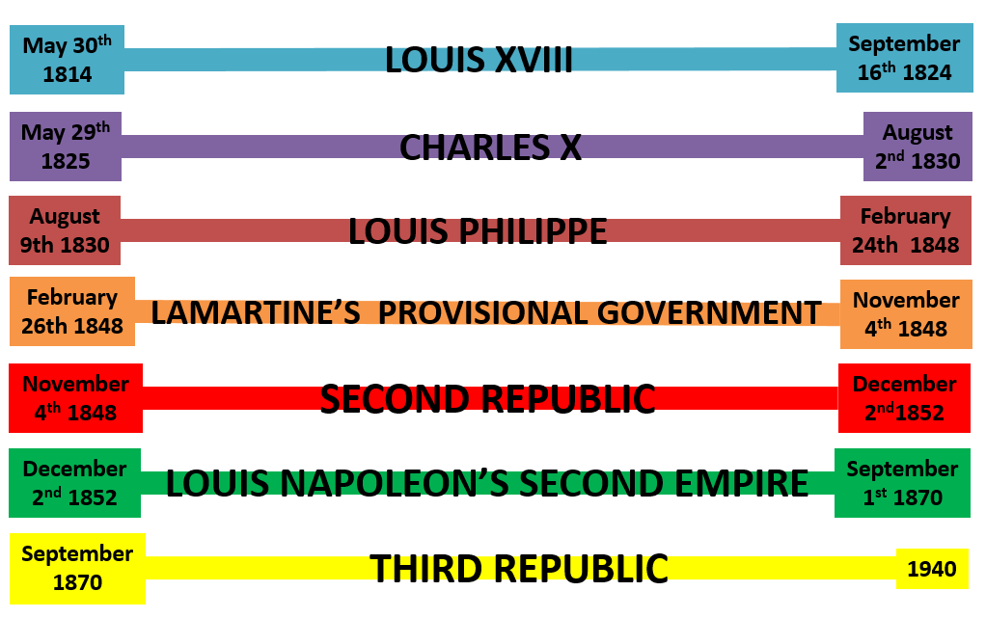
LOUIS XVIII-
1) Paying off indemnities and removing foreign troops from French soil.
2) Re-establishing France internationally

1814: Napoleon abdicated as Emperor after being captured.
1814: September- Vienna Settlement created by the quadruple alliance to reward victors and punish France for the Revolution by turning back the clock. France was forced to pay reparations. Also decided at the Vienna Settlement was the First Treaty of Paris: 1) France retains border of 1792 and some of its foreign colonies. 2) Restoration of the Bourbon monarchy. (Due to Talleyrand who convinced the Allies that Louis XVIII was the best option for France). 3) Charter of 1814 (in accordance with the declaration of Saint-Ouen) guaranteeing a constitution.

1815: February- Napoleon escapes Elba and returns to France proclaiming himself Emperor.
1815: March-June- 100 Day Reign as Napoleon enters Paris. Louis XVIII runs away for protection from France’s recent enemies.
1815: June 18th- Battle of Waterloo. Napoleon is defeated and exiled.
1815: Second Treaty of Paris forced onto France, arguably harsher because of their show of support for Napoleon. 1) Frances borders returned to 1789. 2) Indemnity of 700 Francs. 3) 250 million Francs for army occupation in 17 border fortresses for 5 years.

1818: Congress at Aix La Chapelle: France was included to its first congress, paid off indemnity, army occupation withdrawn, and France given full membership becoming the Quintuple Alliance.

1820: July- Congress of Troppau.
1820: 19th November- Troppau Protocol was signed- Holy alliance promised to turn back clock on countries that had undergone revolution through peaceful/ forceful means. Congress adjourned till 1821 (Congress of Laibach).

1821: January- Congress of Laibach. Invited King of Naples [Britain under Castlereagh approved as the Congress seemed to take a different turn to the congress of Troppau, as it appeared to be about negotiation.] France and Prussia was represented, whilst Russia and Austria’s Emperors were there in person, Britain took a back seat being represented by Lord Stewart who wasn’t given full powers.
1821: May- Congress finished. Naples occupied by Austria. Holy alliance used principle of the Congress of Troppau to find a solution to the Greek War of Independence without support of France or Britain.

1822: October 20th- Congress of Verona- question of restoring the Spanish monarchy put forward. Britain refused (Wellington was representative) and left the congress early, so France went ahead anyway with the support of the other powers.

1823: April- Louis sent 100,000 French troops to support King Ferdinand VII of Spain against liberal rebels who had forced a liberal constitution. Re-establishing France’s power due to quick victory. Absolutism restored in Spain and Spanish Inquisition restarted. Lost support of Britain whose Prime Minister Canning spoke in support of rebels but sent no aid.
1823: Spanish colonies in South America rebelled against Spanish rule and due to their trading links with Britain meant that both France and Spain were threatened with war if there was any intervention, so they desisted.

CHARLES X-
1) France’s interests
2) Religion- Catholicism

1825: Ibrahim Pasha (Egyptian) invaded Greece and began to expel Greek Christians. Britain, France and Russia made an agreement that they would enforce a ‘self-government’ using force (War) if necessary. Joint Naval force sent and quickly drawn into a fight, which they won.

1830: Defeated ‘Barbary Pirates,’ (Arab pirates from North Africa that had been disrupting western trade in the Mediterranean.) gained territory of Algiers, many of his troops were left to build the ‘empire’ (arguably weakened him enough for Revolution to over throw the bourbon monarchy). Created active trading links with Mehemet Ali.

1830: Invasion of Algeria began.
1830: July: Algerian army defeated and France took possession of a coastal strip. Wanted to preserve liberties/ properties/ religious freedom of inhabitants. Although in reality French troops did not follow this (estimated 50million francs were stolen). As the victory was so popular only a portion of soldiers left and though not intended, permanent occupation was needed to keep domestic support.

LOUIS PHILIPPE-
1) “To view an active and independent foreign policy with suspicion.”/ “Natural caution and desire for peace.” [Keith Randell]
2) Understood his place as king of the French was precarious- not legitimate ruler of France. The great powers could impose on them just as they had in 1815. Austria and Russia were “self-appointed policeman of Europe” getting rid of any sign of liberal/ revolutionary occurrences.
3) “Avoid general European War”
4) Become allies with Britain.
5)”dynastic or national ambition”
1830: August- Belgium revolt took place after the revolution in France due in part to long term resentment of the Vienna Settlement (1815) which joined under the Netherlands to create a buffer state. As well as the religious clash – Belgians: Roman Catholic/ Dutch= Protestant. Within a year they had set up a provisional government.
[Despite calls for it, Louis Philippe refused to annex the newly independent Austria for fear of upsetting the Great Powers. Although it made sense e.g. French speakers, similar culture, regain land e.g. natural northern frontier- the River Rhine.] His handling of the situation created an entente with Britain.
1830: France forced to sign a non-intervention agreement to avoid war with the Great Powers.
1830: November- Conference in London between Britain and France. It was decided: 1) Belgium should have independence. 2) Prince Leopold should rule. 3) Imposed armistice in Belgium.

1831: August- Dutch invaded to reclaim Belgium, but was repelled by British and French forces. French troops had to be forced to leave by the other Great Powers.
1831: Ibrahim Pasha invaded Palestine and Syria for his father Mehemet Ali, threatening Turkey (heart of the Sultan Empire). This was because they had not been paid by the Sultan for their help in the Greek War of Independence. Russia was asked to help keep them out of Turkey in return for control of the passageway between the Black sea and the Mediterranean (Treaty of Unkiar-Sklessi). This made things difficult for France as they supported Mehemet Ali as he bought weapons, expertise, and general trade etc from them. But Mehemet Ali was disliked by Britain who wanted to balance power and take away some influence from Mehemet Ali.

1833: After 1823 and the liberal defeat in Spain due in part to France interference in the liberal demise

1834: June- France formally annexed occupied areas of Algeria as a military colony. This was run by a military governor. Continued fighting between French soldiers and local forces of Oran and Constantine as France went further than its borders.

1835: France worked with Britain (Whig party under Viscount Melbourne) to send material aid and organised volunteers to Spain to help the Regent (Maria Cristina of Bourbon-Two Sicilies) get rid of the remaining liberal revolt [Carlist War- 1833-1843]

1837: Crown Prince took part in final capture of Constantine. They then had to fight Al-Qadir for a further 10 years.

1837: Regent in Spain (Maria Cristina of Bourbon-Two Sicilies) accepted a new constitution which gave more power to Spanish parliaments or the cortes.

1839: The Treaty of London: Belgium recognised as an independent country in law and Britain assured that it would guard Belgium’s ‘neutrality’ and prevent invasion. Louis Philippe refused the throne of the independent country for his son in fear that he would never gain an ally and “working relationship” with Britain, despite growing pressure from France to do so [Keith Randall].
1839: Louis Philippe forced to accept Thiers as his leading minister who often expected him to stay as a “figurehead” without power in the day to day running of things. (As only he could command a majority in parliament) Thiers took an “obstructionist” (against the Great Powers) approach to the problem between Mehemet Ali and the Great Powers. Also discarding the idea of a close relationship with Britain in favour of France’s interests.
1839: Due to the Sultans death Britain organised a meeting with the other powers in order to solve the issue of Syria and Palestine through collective action. Although France clearly supported Mehemet Ali, Britain got the support of the other powers to remove the Egyptian’s from Palestine and Syria.
1839: Thiers (who represented France) threatened war but backed down when the other Great Powers went ahead anyway. Thiers was replaced after the King refused to use the army. The ‘entente cordiale’ was broken as France and Britain directly opposed each other.

1840: policy of limited occupation in Constantine abandoned for complete control.

1840: Guizot worked in London as France’s ambassador, and was a friend of Aberdeen [foreign minister 1840-46] (pro- entente between France and Britain)

1842: French admiral convinced The Queen of Tahiti to become a French protectorate. The British Consul was not present, and when he returned he urged the locals to show discontent at the news.

1843: Queen Victoria visited Louis Philippe.
1843: June- France annexed Tahiti and expelled English missionaries and consul (Pritchard). [Guizot was forced to pay compensation but never did!]

1844: Return visit to England from Louis Philippe. (Until Spanish Marriage problems arose in 1846.)
1844: Guizot and Louis Philippe had denounced annexation of Tahiti. War continued between France and the locals till 1847.

1846: Palmerstone became foreign minister, which was a problem to France as they were disliked by him. So when the subject of who Queen Isabella of Spain would marry, unlike Aberdeen -who argued that the issue wasn’t worth a national quarrel-, Palmerstone was unwilling to trust France backing a Saxe-Coburg Prince instead of France’s preferred Duke of Montpensier (Louis Philippe’s youngest son).
[The question of who she should marry aroused in Britain the same fears of a union between French and Spanish crowns that had led to the outbreak of the War of the Spanish Succession (1701-13), though neither country offered such threat to Britain as they had done then.]
1846: It was unofficially agreed between France and Spain that the Queen should marry her cousin Francis instead, but Guizot planned a coup.
1846: He married the Duke of Montpensier to her younger sister instead on the same day in the hope that Isabella would not have children (so France could maintain her position in the Mediterranean as a Great Power). Unfortunately for France, Queen Isabella had a son Ferdinand (1850) creating an empty victory.

1847: 70,000 French colonists in Algeria.. Al-Qadir captured in December.

SECOND REPUBLIC –
- Avoid War
- Not to tarnish first Bonapartist foreign policy with defeat.

1849: April- French expeditionary force sent to Rome in order to mediate a settlement between the Pope and revolutionaries. Also to avoid a humiliating growth of Austrian power and influence as they would eventually attack and take over the Roman Republic. Republicans resisted French intervention. In an effort to not end his first foreign policy in defeat Louis Napoleon ordered French soldiers to fight their way into Rome. Republic Fell and Pope returned.

NAPOLEON III AND THE SECOND EMPIRE–
1) Reverse the 1815 Settlement to undo Napoleons defeat
2) Expansionism/ adventurous foreign policy as a Bonapartist
3) To appease his wife Eugenie

1852: Palmerston acknowledged Napoleon III as leader of France, improving relations with Britain.

1852: Napoleon’s statement “the empire means peace.”

1853: July- Napoleon III organised the Vienna Note [designed to uphold the interests of both France and Russia to find a peaceful alternative to the problem of Holy Places in within Turkey], signed by Britain, Prussia and Austria. This allied them together to protect Christian places in the Ottoman Empire.
1853: October- the Sultan (ruler of Turkey) declared war on the Tsar due to Russian occupation.

1854: March- France and Britain declared war with Russia, with aid from Piedmont (leader- Cavour) [Crimean War]
[As the war dragged on it became increasing unpopular in France and Napoleon sought to end the conflict, causing problems with Britain's leader Palmerston]
1854: British and French State visits by sovereigns

1855: Another British/ French state visit

1856: March- Formal Peace Conference in Paris to ensure peace and end the Crimean war with Russia’s new leader Alexander II. (This placed France at the centre of European affairs). Napoleon wished to turn the Paris conference into a general congress but this wasn’t wanted by the other powers, especially Britain. Cavour had hoped to use this as an opportunity to get Britain and France to help gain support for the North Italian Kingdom, but gained none.

1858: January – Combined with Cavour constantly gaining the Emperor’s attention from threat of revolution, Orsini (a revolutionary) attempted to assassinate Napoleon III and Empress Eugenie. This forced to support Cavour to avoid a Revolution in Italy.
1858: Summer- Napoleon III was convinced to meet Cavour to draw up the Plombieres scheme to remodel Italy to suit France and Piedmont, and also promised France’s support if it was a victim to Austrian attack. Napoleon attempted to call a European Congress to diplomatically find a solution to Italy’s problem, but as no-one would acknowledge that there was an issue.
[When Napoleon wavered in his attempts to get the Great Powers on board Cavour threatened to publish the Plombieres scheme, and continued to aggravate Austria, effectively backing France into a corner]

1859: Austria demanded Piedmont to demobilise their army, (This was classed as an act of war provocation) Napoleon III and France were able to come to Piedmonts aid. The Piedmontesse army invaded Rome. France secured victories in Magenta and Solferino.
1859: July – Napoleon III negotiated an armistice with Franz-Joseph without Cavour on board with the decision. (This was due to the fact that the French army was ravaged by sickness and had lost a great number of soldiers in battle and the hard campaign wasn’t seen as worth it. (W. H. C. Smith.) Also the fact The Great Powers wanted an end to the conflict, especially Britain. With catholic Powers threatening to come to Austria's support.
1859: France reluctantly had to annex Savoy and Nice and created an unreliable Italy as the Plombiere scheme hadn't worked.

1860: Cobden and Chevalier Treaty. International trade agreement- Frances protective duties were reduced to a maximum of 25% within 5 years, and free entry of all French imports (except wine) into Britain.
1852-59

1861: France, Britain and Spain invaded Mexico after Juarez (leader of the republic of Mexico) refused to pay back debts. Once payments resumed Britain and Spain withdrew. But France stayed to create a ‘Catholic Empire’, and also for the trade access to the Atlantic and Pacific Oceans.

1863: Polish Revolt. Polish revolted against Russian rule, Napoleon verbally encouraged but didn’t physically give assistance and watched as they were crushed.

1864: Prussia (under Bismark) invaded Denmark to regain the German Confederation, known as the Danish War. [This showed that there was no entente between Britain and France as Napoleon III was unable to convince Palmerston to help Denmark. Also shown by the fact they had rebuffed his attempts at re-establishing the European Congress.]
1864: France reduced their duties to 20%- Britain allowed free imports for all French products (expect wine).
1864: To regain Austria’s trust Napoleon made Archduke Maximillian Emperor of Mexico.

1865: Napoleon III and Bismark met in Biarritz to find out what Napoleon’s
1866: German states almost completely unified by Bismark after the success of the Austro-Prussian war. Bismark (Chancellor of Prussia) wanted to incorporate the German speaking regions of France- Lorraine, Alsace.
1867: Bismark initially supported Napoleon III in buying Luxembourg as a compromise for not interfering in the Austro-Prussian War. Then Bismark changed his foreign policy and went against France, making Napoleon III look weak to France.
1867: June- Juarez’s men captured Maximillian and he was executed.

1869: Helped to build the Suez Canal in Eygpt- expanding trading routes, markets.

1870: ‘Ems Telegram’ (amended by Bismark to appear as if France had been insulted.) published by Bismark to incite war.
1870: 19th June- War declared on Prussia. Franco-Prussian War.
[PRUSSIA: had superior numbers of soldiers, and general staff which could use those numbers efficiently e.g. move them to the battlefields quickly.]
[FRANCE: Whilst France soldiers mostly arrived late with inadequate supplies]

1870: 1st September- Napoleon III and 84,000 soldiers were surrounded at the Sedan.
1870: 2nd September- Napoleon III surrendered, then captured and imprisoned.

